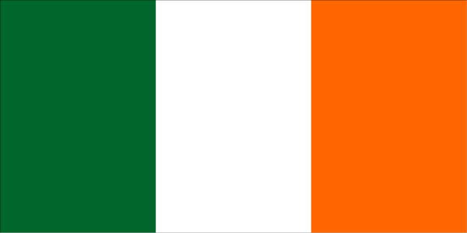
SUNDAY, MARCH 19TH
SUNDAY, MARCH 19TH
Come Celebrate Being Irish

(even if you’re not!)
FOR THE MONTH OF MARCH!

Beginning march 3rd!
ENTERTAINMENT

SUNDAY, MARCH 12TH



WILD ROVER RACE
FEATURING OUR IRISH FOOD & DRINK MENU
*Regular menu also available
DJ STEVE
11:30AM to 3:30PM
TAKE A FLIGHT

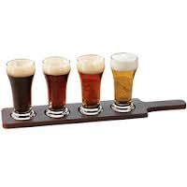
“Playing Your Favorite Irish Tunes”

JERRY MARTINEZ
“Acoustic Soloist”
5PM to 9PM

Guiness
Harp
O’Hara’s Irish Red
Smithwicks

(4) 4 OZ. SERVINGS

$8.35

THURSDAY, MARCH 16TH

FIDDLE HILL
Buy an Owen & Ollie's St. Patrick's Day
Commemorative T-Shirt!
Just $17 for Short Sleeve
$21 for Long Sleeve
$5 Extra for XXL or XXXL

6PM TO 9PM
“Irish Pub Songs & Hot Fiddle Tunes”

FRIDAY
MARCH 17TH
TO IRELAND

DJ STEVE
11AM to 4PM
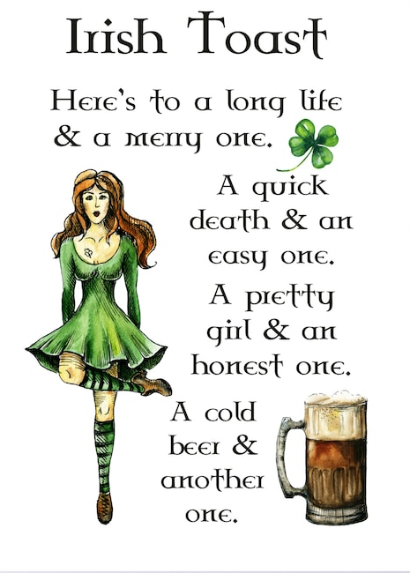
“Playing Your Favorite Irish Tunes”
*Special Appearance by O’Halloran
Irish Step Dancers

JUG OF PUNCH
5PM to 10PM
“5 Piece Irish Party Band”

SATURDAY, MARCH 18TH
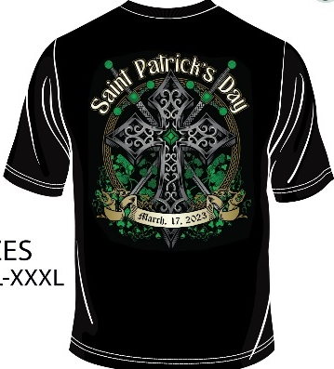
JOE LEARY
5PM to 9PM
“Irish Country Acoustic Soloist”
*Special Appearance by
Commonwealth Pipes & Drums
(Bagpipers)
$49
For Hoodies

SUNDAY, MARCH 19TH

KATIE OBRIEN TRIO
5PM to 9PM

